Individualized Plaque Control Heat Map
Patient name: ______________________________ Record # _____________________
Plaque Control Record (O’Leary et al. 1972)
Plaque Index (Loe 1967) and Quigley-Hein Index (Turesky et al., 1970)
0 = plaque free
1 = a thin film or flecks of plaque (hardly visualize without disclosing agent)
2 = moderate accumulation of soft deposits (thick> 1mm or covered within cervical third surface)
3 = abundance of soft matter. Food impaction between teeth.

Date: ________________  Purpose of the Visit: __________________________ | Define the major hot spots:
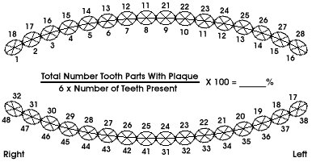
Date: ________________  Purpose of the Visit: __________________________ | Customized adjunctive aids and technique over hot spot with video demo sent to patient
What’s in your customized video?

*Hot spot plaque index average reduction: From ____________________ to ___________________ (0-3)

